Assignment 2
PNR: 260740150018
Name: PRATIK SUNIL ABHANG
Question:
Create a list of integers:
1. Find the sum of all elements
2. Find the maximum and minimum element
3. Sort the list in ascending order
Program
print('by default')
list1 = [10, 20, 30, 45, 25, 50, 85, 75, 35, 64]
print('list:', list1)
print('sum of all elements:', sum(list1))
print('maximum element:', max(list1))
print('minimum element:', min(list1))
list1.sort()
print('ascending order:', list1)
print('\nby user')
list_user = []
n = int(input("enter no. of elements: "))
for i in range(n):
element = int(input(f"enter element {i+1}: "))
list_user.append(element)
print('user list:', list_user)
print('sum of all elements:', sum(list_user))
print('maximum element:', max(list_user))
print('minimum element:', min(list_user))
list_user.sort()
print('ascending order:', list_user)

Input and Output
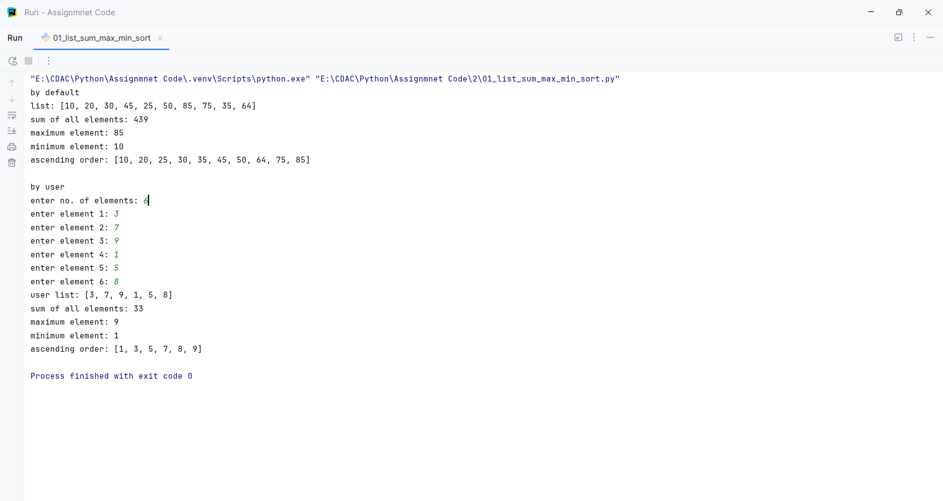
Question:
Write a program to remove duplicate elements from a list.
Program
list1 = [1, 25, 50, 50, 75, 100, 125, 125]
print('original list:', list1)
list_nodup = list(set(list1))
print('no duplicate list:', list_nodup)

Input and Output
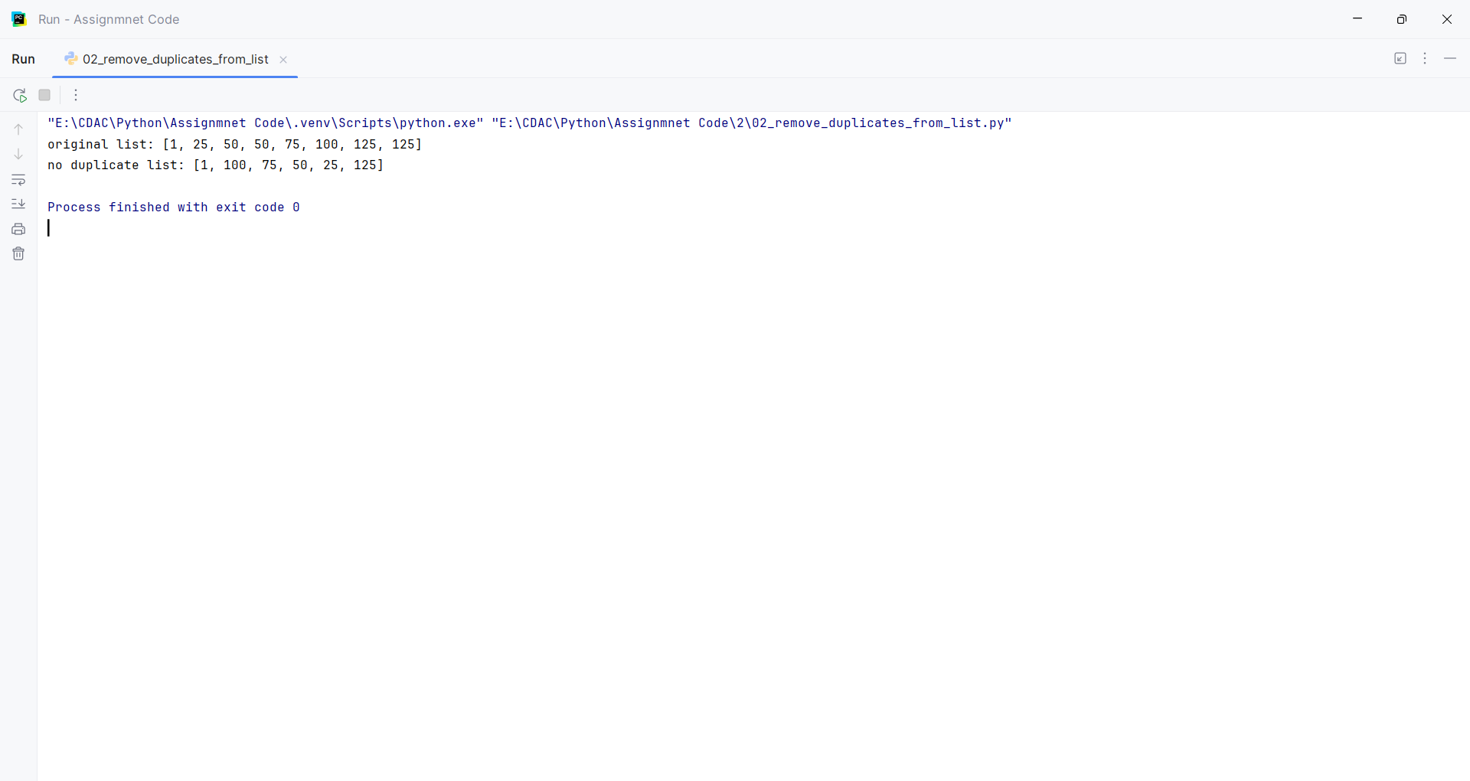
Question:
Create a tuple of numbers and:
1. Find the length
2. Find the largest and smallest value
Program
print('by default')
tuple1 = (1, 2, 3, 4, 5)
print('tuple:', tuple1)
print('length:', len(tuple1))
print('largest element:', max(tuple1))
print('smallest element:', min(tuple1))
print('\nby user')
list_user = []
n = int(input("enter no. of elements: "))
for i in range(n):
element = int(input(f"enter element {i+1}: "))
list_user.append(element)
tuple_user = tuple(list_user)
print('tuple:', tuple_user)
print('length:', len(tuple_user))
print('largest element:', max(tuple_user))
print('smallest element:', min(tuple_user))

Input and Output
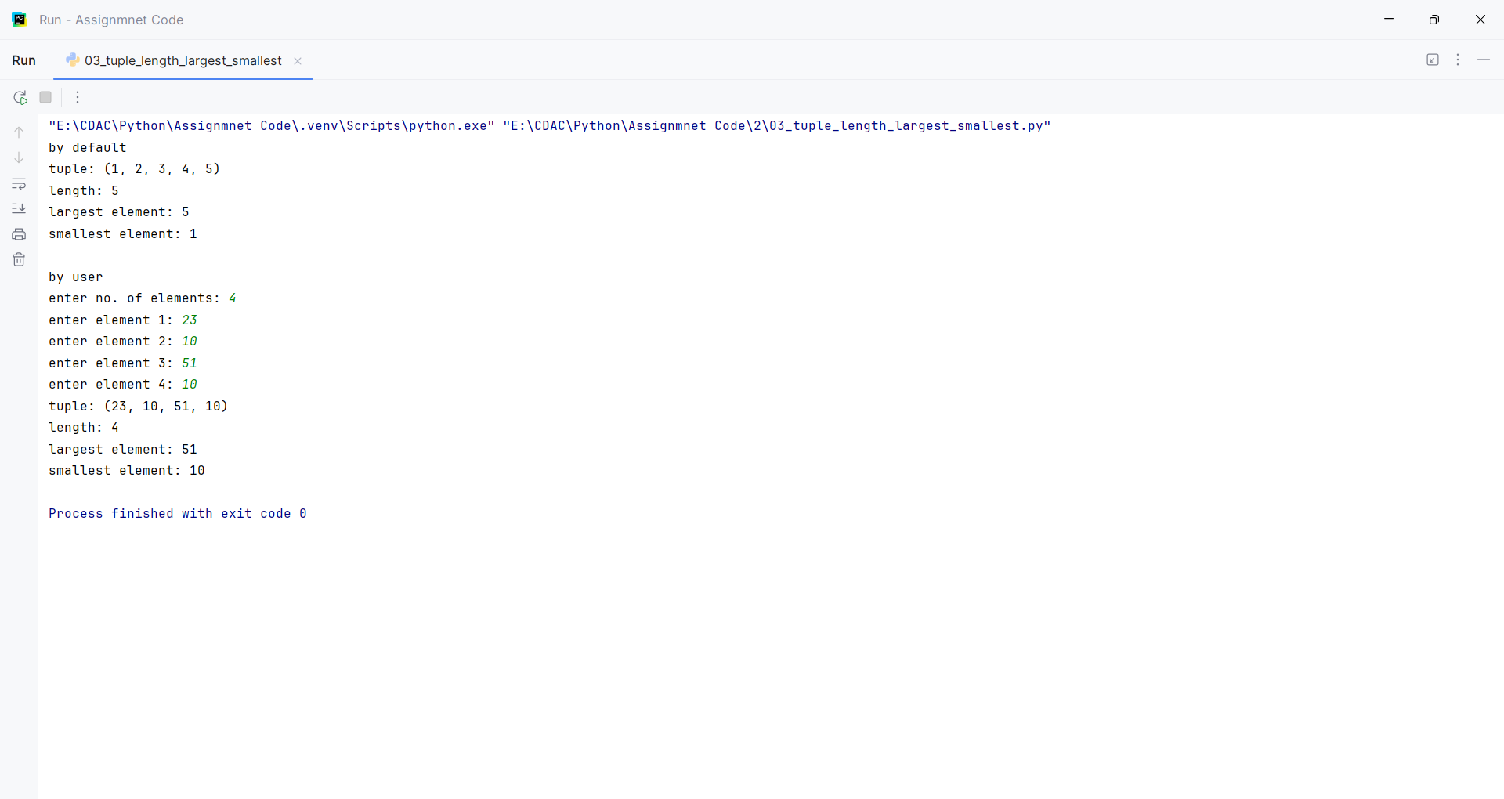
Question:
Convert a tuple into a list and add a new element.
Program
tuple1 = (10, 20, 30, 40)
print('tuple:', tuple1)
list1 = list(tuple1)
list1.append(50)
print('tuple to list conversion:', list1)

Input and Output
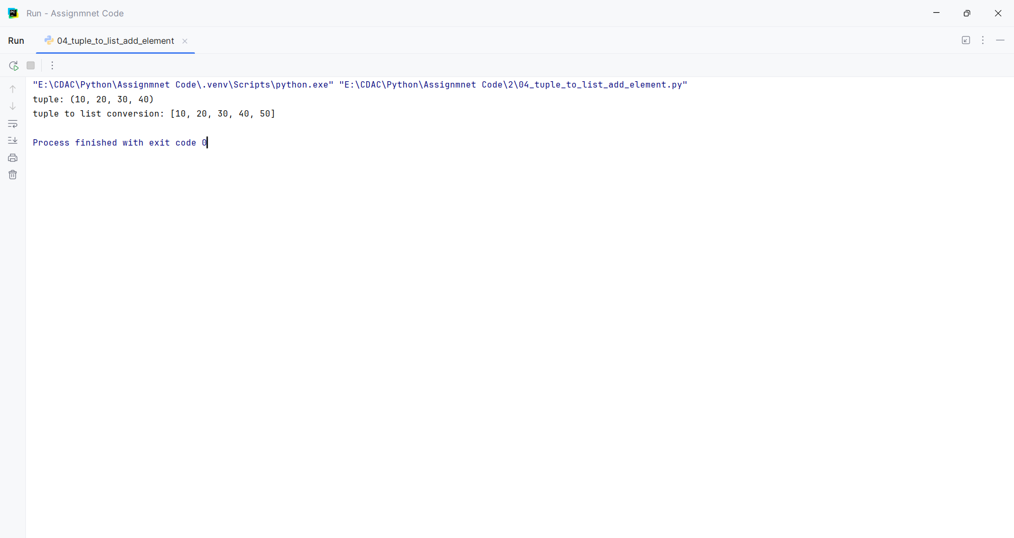
Question:
Write a program to:
1. Count vowels in a string
2. Reverse the string
Program
print('by default')
text = "hello world"
rev_string = text[::-1]
print('string:', text)
print('reversed string:', rev_string)
vowels = ['a', 'e', 'i', 'o', 'u', 'A', 'E', 'I', 'O', 'U']
counter = 0
for letter in rev_string:
if letter in vowels:
counter = counter + 1
print('vowels count:', counter)
print('\nby user')
text = input("enter a string: ")
rev_string = text[::-1]
counter = 0
for letter in rev_string:
if letter in vowels:
counter = counter + 1
print('string:', text)
print('reversed string:', rev_string)
print('vowels count:', counter)

Input and Output
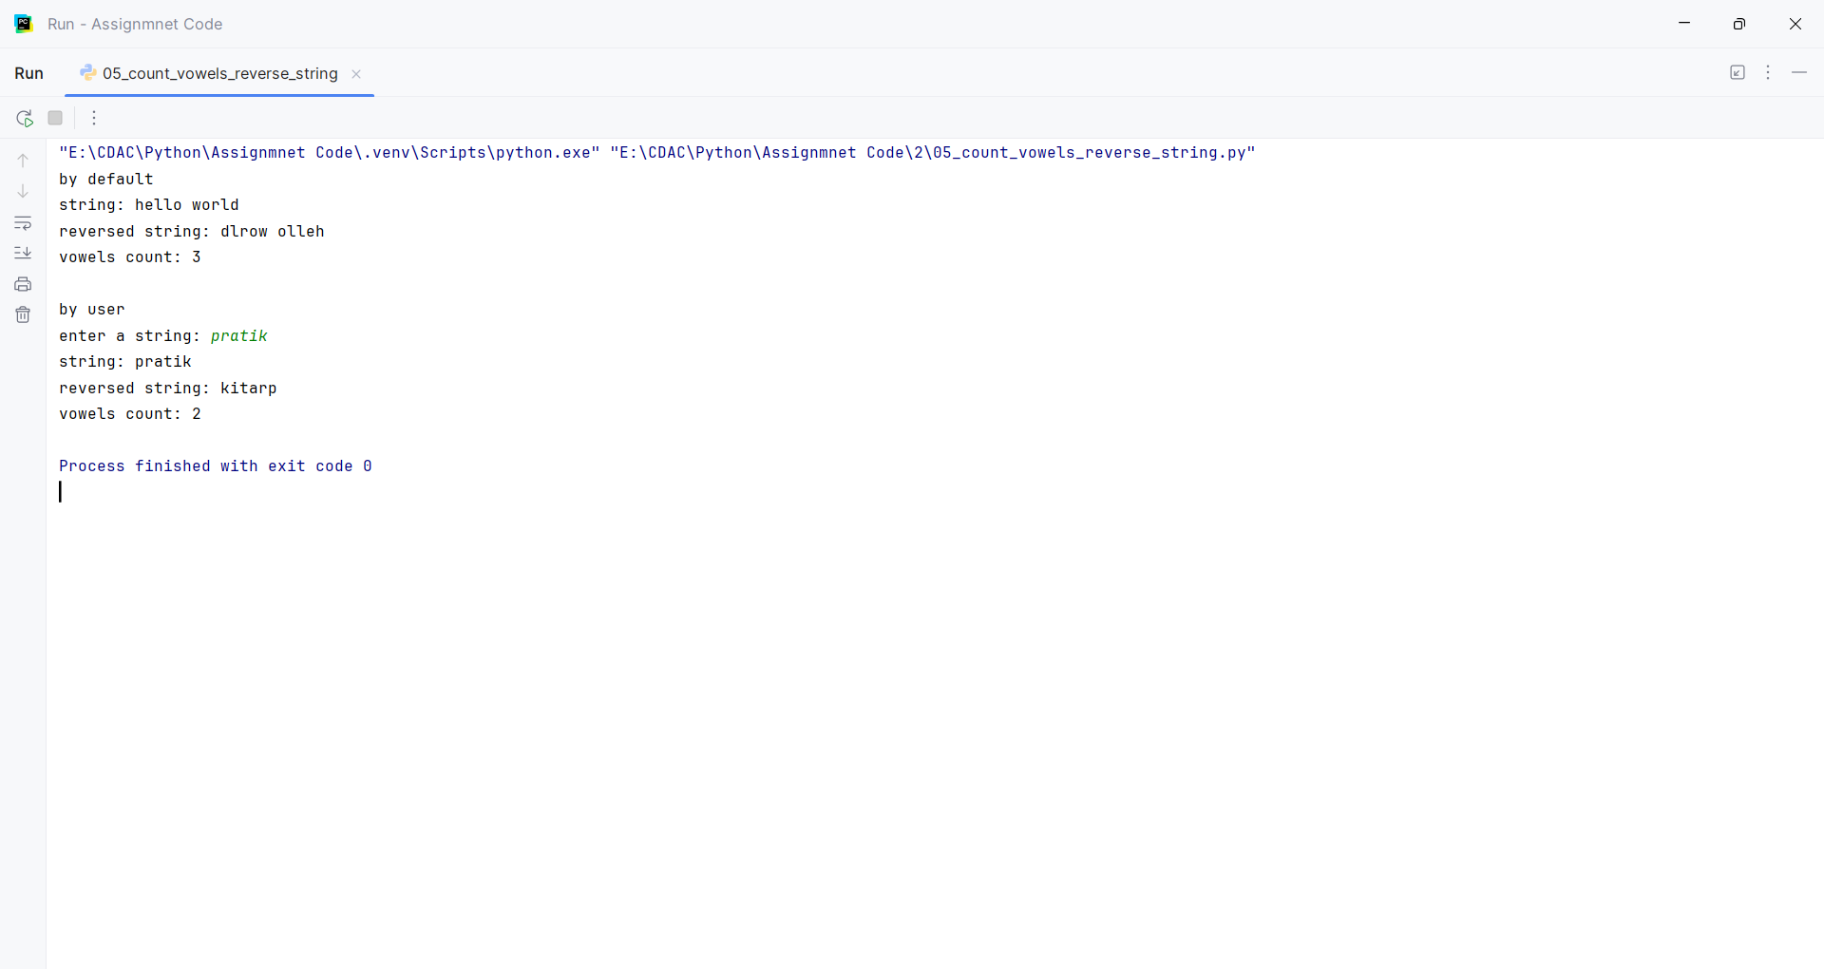
Question:
Check whether a string is a palindrome.
Program
print('by default')
word = "radar"
backward_word = word[::-1]
if word == backward_word:
print(f"Yes, '{word}' is a palindrome!")
else:
print(f"No, '{word}' is NOT a palindrome.")
print('\nby user')
word = input("enter a string: ")
backward_word = word[::-1]
if word == backward_word:
print(f"Yes, '{word}' is a palindrome!")
else:
print(f"No, '{word}' is NOT a palindrome.")

Input and Output
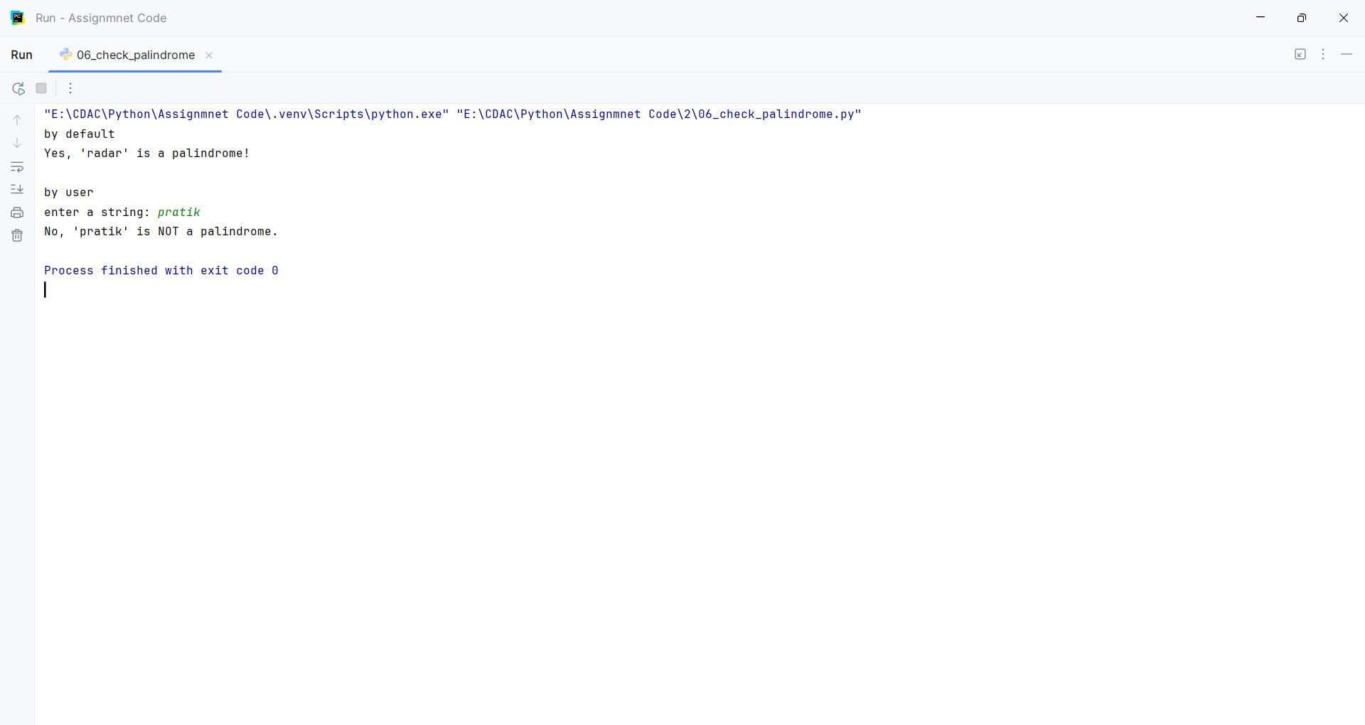
Question:
Create a dictionary of students and their marks. Display students scoring more than 75.
Program
students = {"pratik": 85,"ram": 72,"rohit": 64, "abhi":82, "parth":80}
for name, mark in students.items():
if mark > 75:
print("Students with marks more than 75:",name,":",mark)

Input and Output
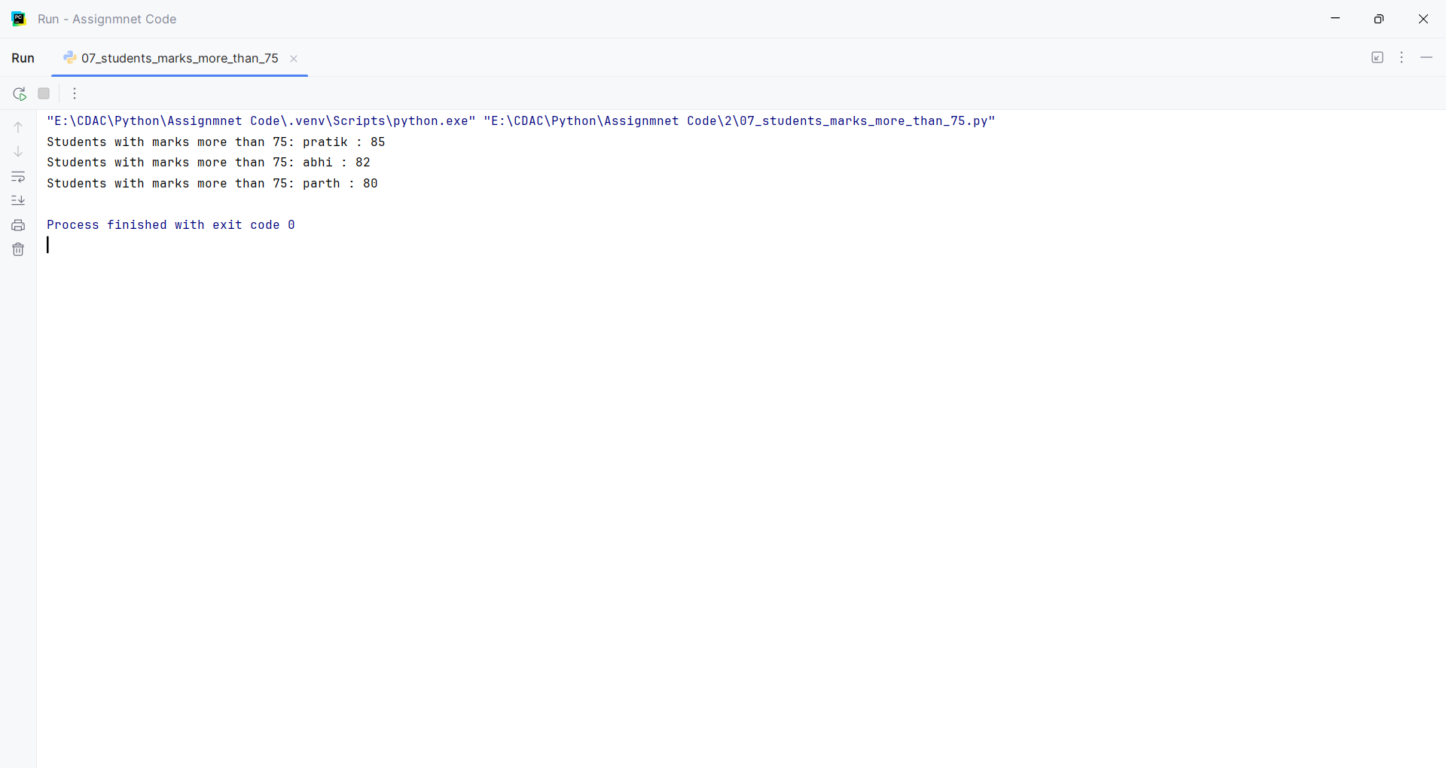
Question:
Add a new key-value pair and update an existing value.
Program
print('by default')
students = {
"pratik": 85,
"ram": 72,
"rohit": 64,
"abhi": 82,
"parth": 80
}
print('original dictionary:', students)
for name, mark in students.items():
if mark > 75:
print("Students with marks more than 75:",name,":",mark)
students["aditya"] = 90
students["ram"] = 78
print('updated dictionary:', students)

Input and Output
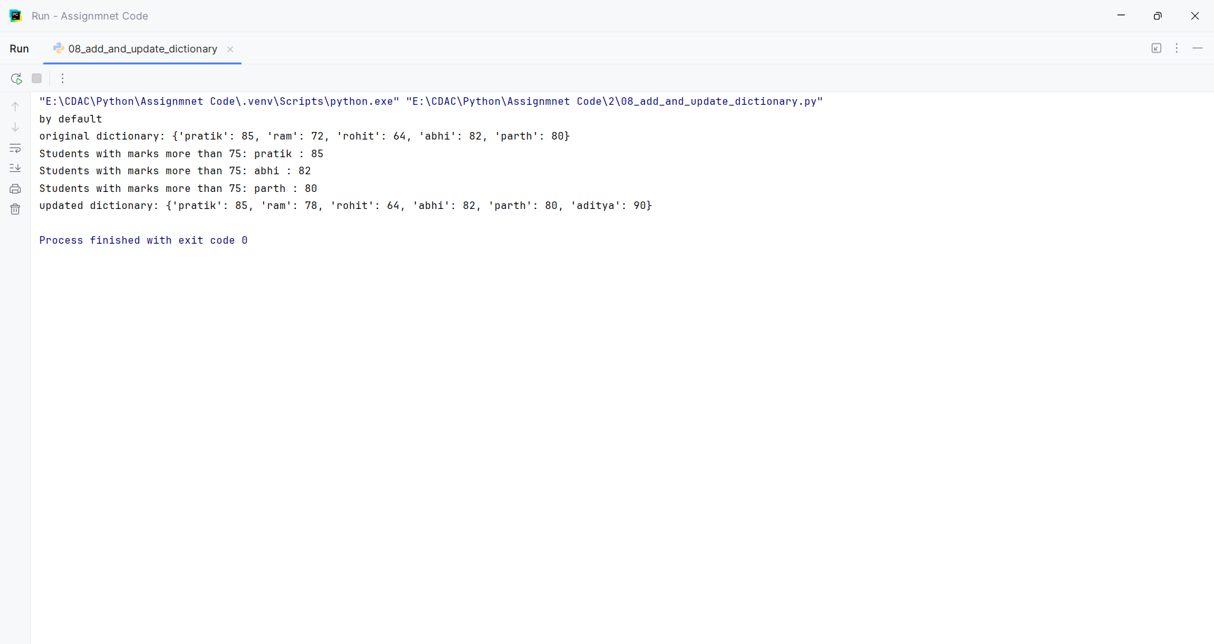
Question:
Create two sets and perform:
1. Union
2. Intersection
3. Difference
Program
set_a = {"pratik", "ram", "rohit", "aditya", "parth"}
set_b = {"rohit", "aditya", "rahul", "amit", "neha"}
print('set a:', set_a)
print('set b:', set_b)
print('union:', set_a.union(set_b))
print('intersection:', set_a.intersection(set_b))
print('difference:', set_a.difference(set_b))

Input and Output
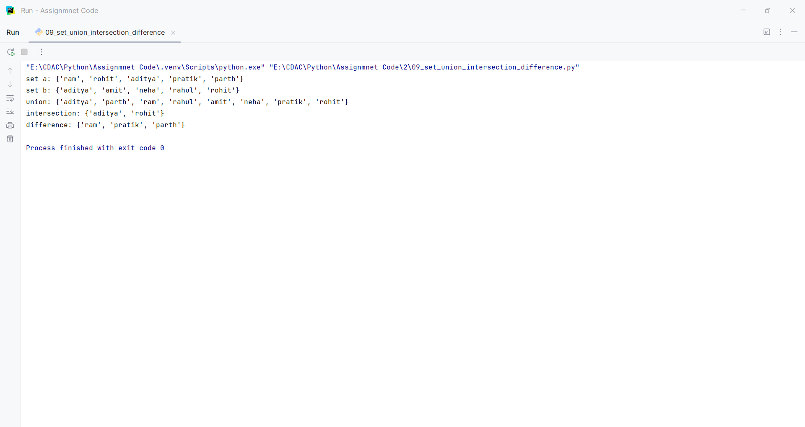
Question:
Write a program to remove common elements from two sets.
Program
print('by default')
set_a = {10, 20, 30, 40}
set_b = {30, 40, 50, 60}
no_commons = set_a.symmetric_difference(set_b)
print('set a:', set_a)
print('set b:', set_b)
print('after removing common elements:', no_commons)

Input and Output
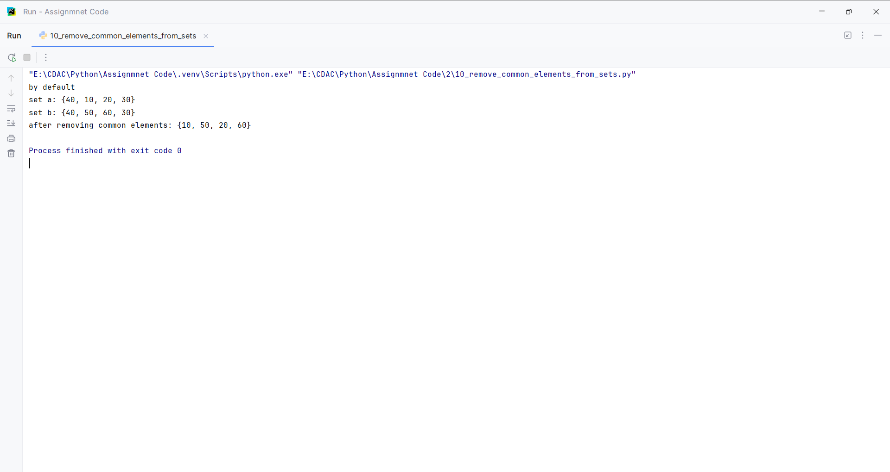
Question:
Write a program to find the second largest element in a list.
Program
print('by default')
numbers = [12, 45, 2, 99, 45, 23, 99, 8]
unique_numbers = list(set(numbers))
unique_numbers.sort()
second_largest = unique_numbers[-2]
print('original list:', numbers)
print('no duplicate list:', unique_numbers)
print('second largest element:', second_largest)
print('\nby user')
numbers = []
n = int(input("enter no. of elements: "))
for i in range(n):
element = int(input(f"enter element {i+1}: "))
numbers.append(element)
unique_numbers = list(set(numbers))
unique_numbers.sort()
if len(unique_numbers) >= 2:
second_largest = unique_numbers[-2]
print('original list:', numbers)
print('no duplicate list:', unique_numbers)
print('second largest element:', second_largest)
else:
print('enter at least two different numbers.')

Input and Output
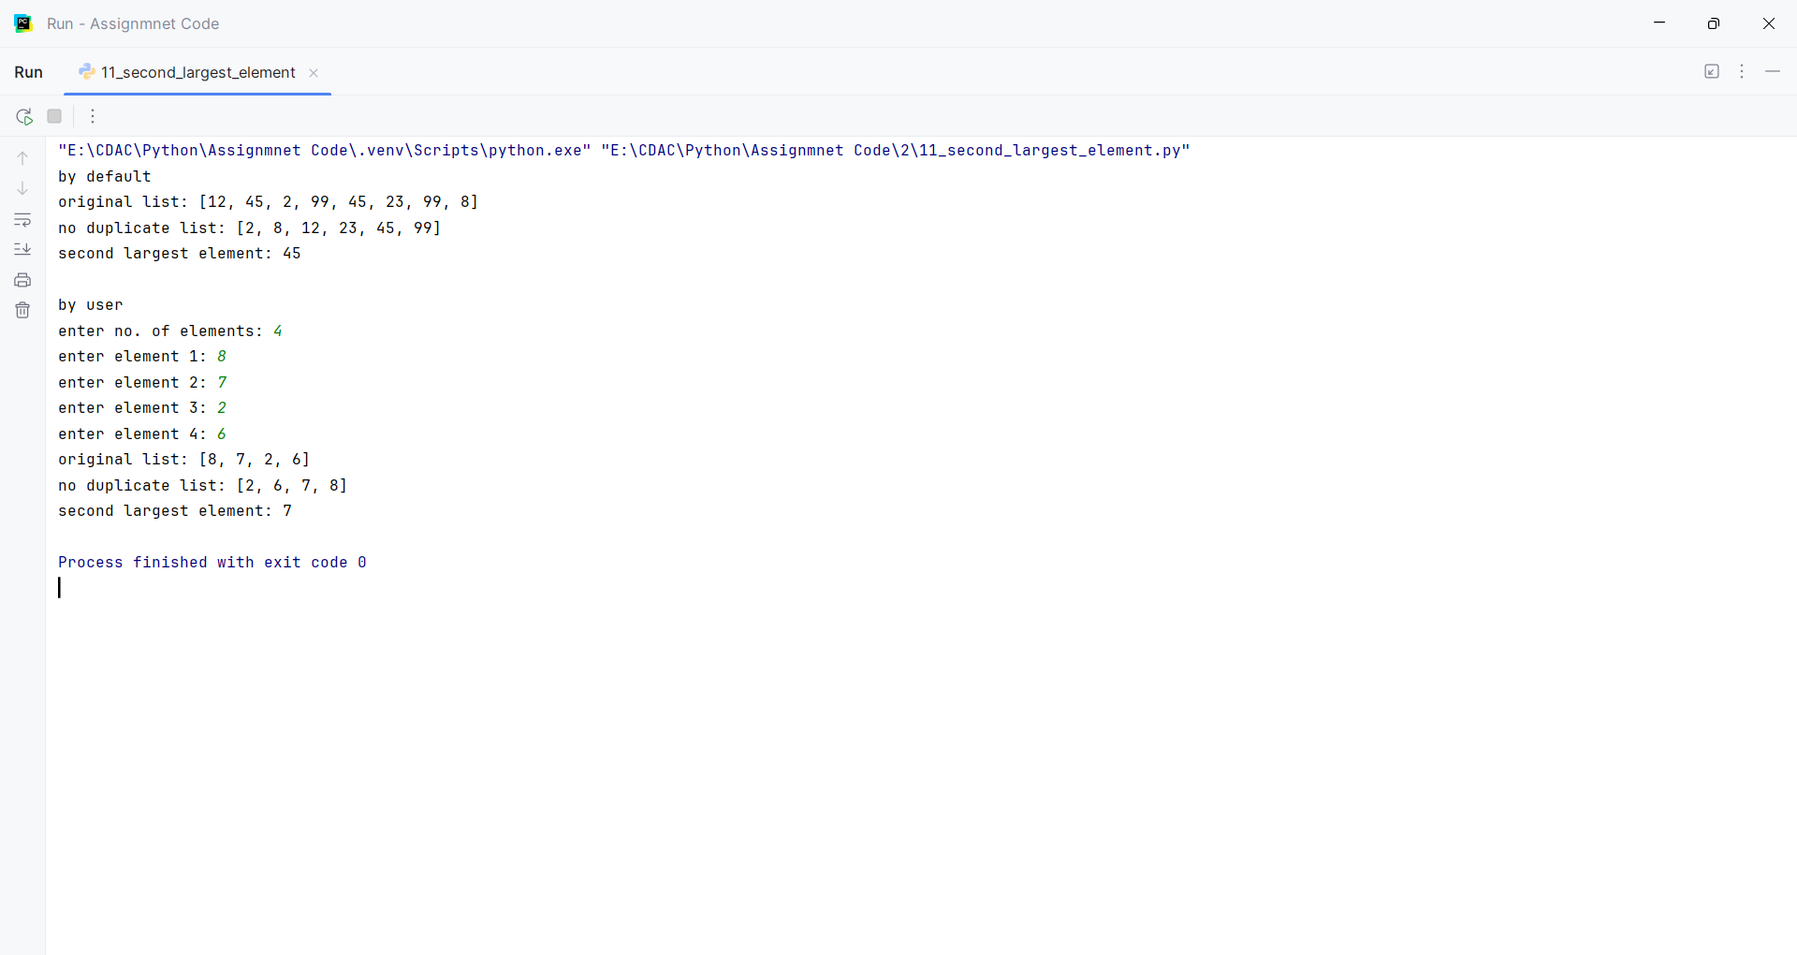
Question:
Write a program to split a list into even and odd numbers.
Program
print('by default')
numbers = [12, 45, 2, 99, 23, 8]
even_list = []
odd_list = []
for num in numbers:
if num % 2 == 0:
even_list.append(num)
else:
odd_list.append(num)
print('original list:', numbers)
print('even numbers:', even_list)
print('odd numbers:', odd_list)
print('\nby user')
numbers = []
even_list = []
odd_list = []
n = int(input("enter no. of elements: "))
for i in range(n):
num = int(input(f"enter element {i+1}: "))
numbers.append(num)
for num in numbers:
if num % 2 == 0:
even_list.append(num)
else:
odd_list.append(num)
print('original list:', numbers)
print('even numbers:', even_list)
print('odd numbers:', odd_list)

Input and Output
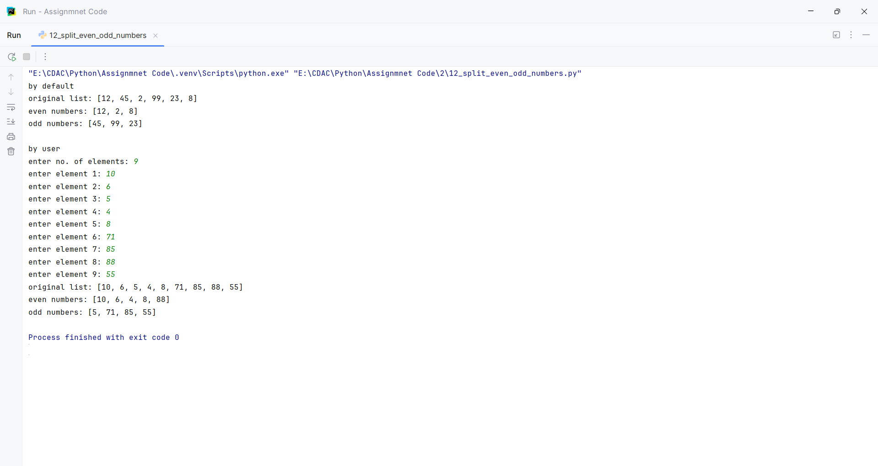
Question:
Write a program to merge two lists without duplicates.
Program
list1 = [10, 20, 30, 40]
list2 = [30, 40, 50, 60]
list_merge = list(set(list1 + list2))
print('list1:', list1)
print('list2:', list2)
print('merge list without duplicates:', list_merge)

Input and Output
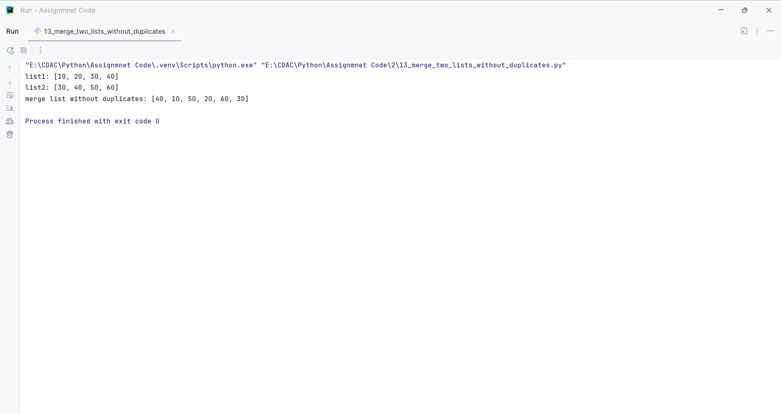
Question:
Find the index of an element in a tuple.
Program
my_tuple = (10, 20, 30, 40, 50)
search_for = 40
print('tuple:', my_tuple)
print('element:', search_for)
if search_for in my_tuple:
position = my_tuple.index(search_for)
print(f"The number {search_for} is at index position: {position}")
else:
print(f"The number {search_for} is not in the tuple.")

Input and Output
